October 25, 2023

The Honorable Cori Bush
Ranking Member House Oversight
Subcommittee on Economic Growth,
Energy Policy, and Regulatory Affairs
2157 Rayburn House Office Building Washington, D.C. 20515

Dear Representatives Bush:

The Sheet Metal and Air Conditioning Contractors' National Association (SMACNA) is supported by more than 3,500 construction firms specializing in industrial, commercial, residential, architectural and specialty sheet metal and air conditioning construction in public and private markets throughout the United States. While many of our members are of significant size and provide a wide scope of expert construction services on major projects, the majority of these contractors operate family-owned businesses with a highly skilled workforce. This industry profile explains why these firms, providing expertise far above industry standards, rely on their local Department of Labor (DOL) registered apprenticeship programs to provide them with quality certified skilled workers.

SMACNA, as a leader in the highest skill segment of the construction industry, shares the goals of those seeking certified apprenticeship programs necessary to produce our nation’s most skilled workforce.

SMACNA contractors invest great amounts of resources to provide their employees the highest quality certified training in a safe environment. This training that allows workers to not only acquire first-rate marketable skills but forges the path to a lifelong career in the construction industry. Further, we offer a leading pay and benefits package appropriate for attracting a high skilled and trained workforce.
More than 10,000 apprentices are registered in affiliated training facilities in the United States and Canada.

SMACNA and SMART, the International Association of Sheet Metal Air, Rail and Transportation Workers (formerly the Sheet Metal Workers’ International Association) have jointly established the International Training Institute (“ITI”) which supports apprenticeship and advanced career training for union workers in the sheet metal industry throughout the United States and Canada. The ITI produces a standardized sheet metal curriculum supported by a wide variety of training materials free of charge to sheet metal apprentices and journeymen. Through the ITI, SMACNA and SMART support locally established registered apprenticeship programs which tailor their training to the needs of the local markets, apprentices and contractors.

The registered apprenticeship programs sponsored by SMACNA contractors and their SMART union labor counterparts, had a national and local combined training investment of seventy-three million dollars in their training programs, with more than fourteen thousand pre and indentured apprentices being trained as of the beginning in recent years. SMACNA is but a small part of the vast network of certified and registered apprenticeship already available in the constructions industry. As noted, by DOL statistics, construction represents 48% of all registered apprenticeship programs in the United States.

SMACNA offers the following recommendations and comments concerning registered apprenticeship:

RECOMMENDED MODIFICATIONS TO FEDERAL STANDARDS FOR
OVERSIGHT OF REGISTERED APPRENTICESHIP PROGRAMS (RAPS)

- Demonstration of Financial Sustainability: The Office of Apprenticeship should modify Part 29 to require sponsors to demonstrate the financial sustainability of a proposed RAP for a period of at least five years, with the following information:

- submission of a detailed five-year budget (e.g., personnel, maintenance of facilities, insurance, equipment, etc.) based on the projected number of registered apprentices and anticipated ratios of instructors and mentors to apprentices;
- identification of participating employers, funding source(s), and the amount(s) of the financial obligations of each source;
- submission of a signed, enforceable agreement(s) documenting the amount, timing, and duration of each contributor’s financial commitment to the program;
- documentation that providers of on-the-job learning have demonstrated the ability to provide broad-based training in the “apprenticeable” occupation;
- costs (if any) of related instruction expected to be absorbed by apprentices;
- proof that the sponsor has reliable access to facilities for hands-on training that adequately replicates the on-the-job experience.

- Upgraded Safety and Health Standards in Hazardous Industries: Part 29 should mandate a minimum number of hours of safety training prior to dispatch to job sites in industries with high rates of injuries.

- Prevent Downgrading of Area Training Standards: Part 29 should adopt, with an important specification, the Nevada model for approval of RAPs, which provides that the State Apprenticeship Council “shall not approve” a proposed program “unless the program requires the completion of at least as many hours of on-the-job learning or the demonstration of at least the same number and quality of skills, or both, as applicable, as all existing approved and registered programs in the relevant skilled trade.” Part 29 should specify that the delivery of related instruction include at least the same number of hours of in-person and synchronous on-line instruction as existing and approved RAPs and at the same or lower costs (if any costs).

- Ensure that RAPs Provide Broad-Based Training in a Marketable Occupation: Part 29 should adopt the Washington State model for determining whether an occupation is “apprenticeable,” which disallows approval of proposed occupation if it is “part of an occupation previously recognized by the registering agency as apprenticeable.” This approach prevents approval of programs that train workers on a limited number of discrete tasks rather than providing broad-based training in a marketable occupation. In the construction industry, circumscribed training on repetitive tasks is known as “de-skilling” a trade for the purpose of wage suppression.

- Corrective Action Plans to Address Deficiencies in Past Performance: Part 29 should withhold approval of a sponsor’s new RAPs unless the sponsor submits and implements a detailed corrective action plans to correct deficiencies in the management, operation, and funding of prior and current RAPs.

- Prevent Evasion of Responsibility for Poor Past Performance: Part 29 should prevent sponsors from evading responsibility for poor past performance by seeking approval of a new RAP under the name of a family member or another entity in which it has an interest.

- Coordination with the Wage and Hour Division of the U.S. DOL to Prevent Exploitation of Apprentices: Improved coordination between the Office of Apprenticeship and the WHD would better safeguard the welfare of apprentices. On Davis-Bacon projects, the failure to pay a progressively increasing schedule of wages, for example, is both a violation of apprenticeship standards and federal prevailing wage law.

- Debarred or Suspended Sponsors and Interested Parties: Part 29 should disallow sponsors and interested parties that are debarred or suspended from government contracts from registering new RAPs during the term of the debarment or suspension.

- Affirmative Action and Diversity: Part 30 should be amended to eliminate the exemption from affirmative action obligations for RAPs with fewer than five apprentices. The Office of Apprenticeship has estimated that 75% of sponsors have fewer than five apprentices.

Sincerely,
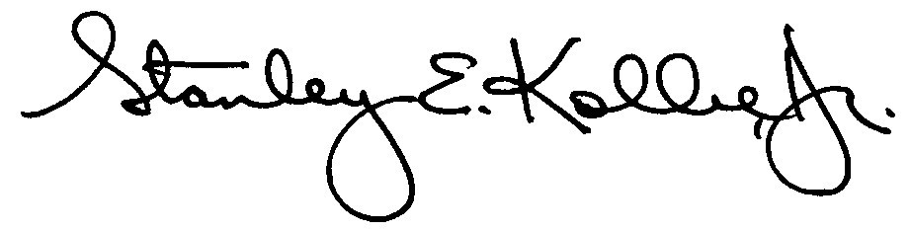
Stanley E. Kolbe, Jr.
Executive Director, Governmental and Political Affairs

See Cal. Code Regs., Tit. 8, §212.2, Eligibility and Procedure for DAS Approval of an Apprenticeship Program. See also, RCW § 49.04.050(2), Apprenticeship Program Standards; Md. Rules § 09.12.43.12. Financial Aspects of the Program Sponsor; and Or. Admin. R. 839-011-0084(3)(c)(A)-(D), Apprenticeship and Training Committees — Approval of New Programs and Standards.
NRS § 610.144(2), Requirements for program to be eligible for registration and approval by State Apprenticeship Council.
Washington Administrative Code 296-05-003, Definitions.

